

Simulation Project 3

EML 6351

by

Aahlad Vanam

13681791

**Dynamic model:**

This is in the form of -----------------------(1)

(b) Problem definition and open-loop error system development:

Open Loop error system:

(c) Control design (including adaptive update law) and closed-loop error system development:

=

***Concurrent Learning based adaptive update law:***

***Integrated Concurrent Learning based adaptive update law:***

3)

1. Simulation Section:

**Concurrent Learning based adaptive update law**

1. Control Gains used:

K = 5

Kcl = 0.00001

a = 0.3

gamma =

20 0 0 0 0

0 5 0 0 0

0 0 5 0 0

0 0 0 40 0

0 0 0 0 5

1. Tracking Error Plot:



1. Control input plot:



1. Plot of the adaptive estimates:



1. Plot of Minimum Eigenvalue:

Fill this later

1. Plot of Parameter estimate errors:



**Integral Concurrent learning based adaptive update law:**

1. List of Control Gains:

gamma =

20 0 0 0 0

0 5 0 0 0

0 0 5 0 0

0 0 0 40 0

0 0 0 0 5

K = 5

Kicl = 0.00001

a = 0.3

1. Tracking error plot for each link:



1. Control input plot for each link:



1. Plot of the adaptive estimates:



1. Plot of the minimum eigenvalue of :

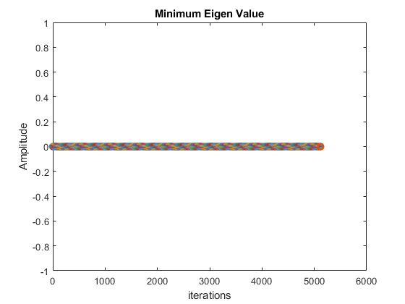

1. Plot of parameter estimate errors:



**Standard adaptive controller with gradient adaptive update law:**

1. Control gains:

K = 7

a = 0.5

gamma = [9 0 0 0 0;0 5 0 0 0; 0 0 5 0 0; 0 0 0 50 0; 0 0 0 0 5]

beta = 2

1. Tracking error plot:



1. Control input plot:



1. Plot of adaptive estimates:





1. Minimum eigenvalue of summation:

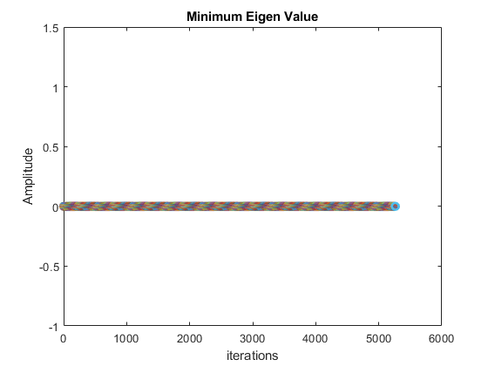

1. **Discussion Section:**
2. Tuning adaptation gains had the most effect on the convergence of errors, control gains were tuned in order to improve the performance of the controllers.
3. Performance of tracking error increasing from standard adaptive controller to the ICL based adaptive controller.



We observe the errors go to zero faster as we go from standard adaptive to ICL controller. In addition to that the ICL has fewer oscillations from t = 30s as compared to the former controllers. In the case of CL the errors oscillate with very low amplitude unlike standard adaptive controller.

1. Performance of adaptation for each case:

Standard adaptive CL adaptive





ICL adaptive

From the above graphs we see that adaptive estimates are converging fastest in ICL and slowest in standard adaptive.

For the Minimum Eigenvalue graph, we used iterations instead of timestamps because the time steps are short, and we visualize better with iterations.

Other Observations:

* The simulated performance resembles closely to the theoretical one.
* Steady state error is the lowest for ICL but not too different from CL. However as compared to standard one, the steady state error is noticeably lower for the CL and ICL controllers.
* First controller has an asymptotic result (like theory), second and third controller an exponential bound and decrease exponential after reaching the minimum eigen value (as expected)
* To achieve this performance for CL controller we needed 7% of max torque for link 2 and 1.2% of max Torque for Link 1.  
  With the same torque we could achieve better performance for ICL controller, however standard controller at similar torque performed poorly in comparison.
* In terms of computational effort, CL and ICL run for same time, almost even in terms of performance. However, errors go down faster in CL, ICL as compared to standard one so we need less computational time for the former case. In this simulation that can be seen to be the case, but we can further tune the standard controller to make sure the errors go down faster thereby not leaving much computational difference.
* In this simulation, we got exponential convergence after reaching minimum eigen value, which is different from the asymptotic tracking of the previous simulations.